**LINUX**

**MOCK TEST – I**

**KARAN S**

1. You are assigned the task of crafting a user account labeled developer with specific characteristics:

The user's primary directory must be located at /home/dev.

The account needs to be enrolled in both the staff and developers groups.

The password for the account should be active by default, and the account should not be disabled. Ensure no immediate restrictions on password expiration.

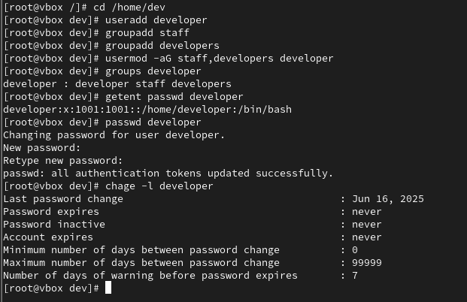

2. You need to manipulate the password settings for a user john to fulfill these requirements:

Enforce an automatic password expiration after a span of 60 days.

Impose a restriction such that john cannot modify their password within the first 30 days from the last change.

Provide the exact commands for these password policies.

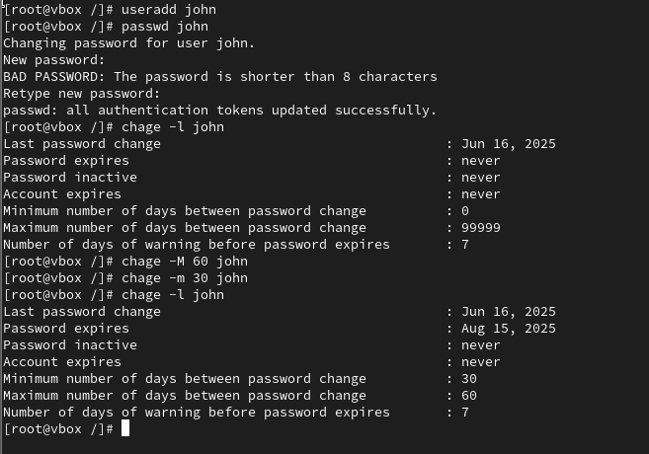

3. A directory named /data/shared has specific ownership and permissions. The user alice must modify the permissions to:

Allow developers group members to create, delete, and edit files within /data/shared.

Ensure that users who are not part of the developers group have only read and execute access to the files, without modification rights.

List the precise commands Alice must use to configure these permissions correctly.

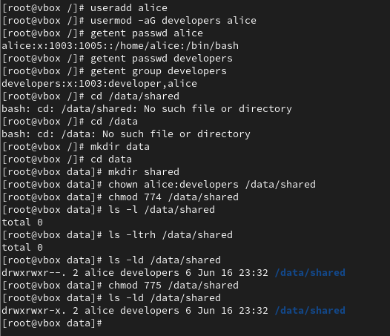

4. In an environment where three groups, admins, staff, and dev, already exist, the requirement is to remove all members from the staff group, leaving only alice in that group. Additionally, alice should be promoted to the admins group. Detail the commands needed to achieve this.

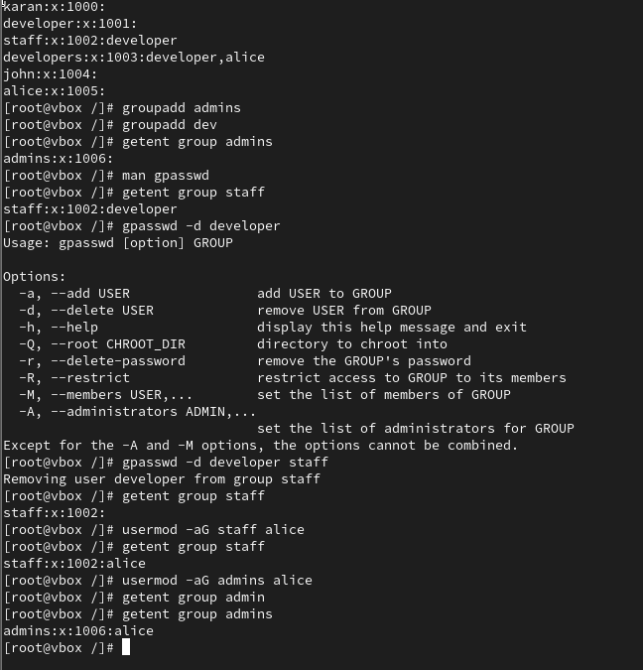

5. You have been alerted that bob’s account has been temporarily disabled due to a security breach. Write the commands necessary to lock and unlock bob's user account.

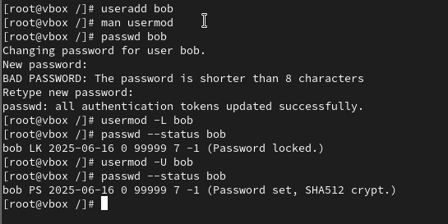

6. Your task is to create a user account alies with the following specific conditions:

UID should be exactly 1326.

The username is alies.

Write the command to create this user.

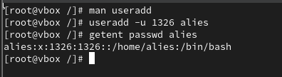

7. In a scenario where devops is an important group, perform the following tasks:

Ensure that only users with the correct password can add or remove members from the devops group.

Add jane to the devops group.

Remove dave from the devops group.

Provide the sequence of commands to implement these actions.

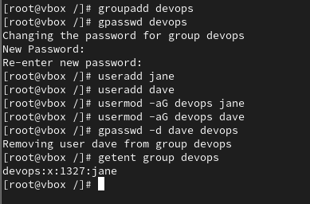

8. Create a new user account project_admin, who should be added to the admins group. This user must have specific permission settings:

The user should be allowed to execute scripts within /opt/scripts/ only if the script files are owned by project_admin or the admins group.

Other users should have only read and execute permissions on the files in /opt/scripts/, but no write or execute rights.

Ensure project_admin is restricted from modifying their password or shell settings.

What set of commands will accomplish these goals?

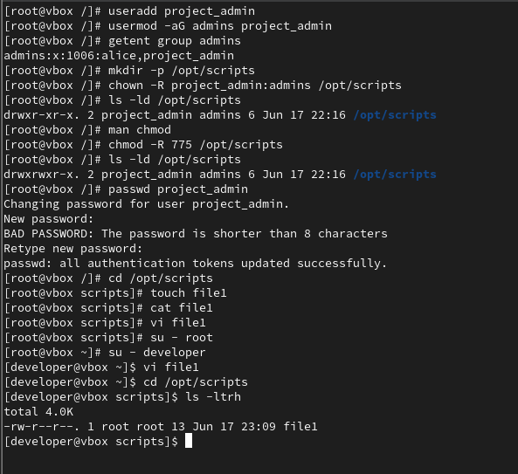

9. You’re tasked with copying files from the directory /data/project to /data/archive. The user alice owns the files in /data/project (with UID 1001 and GID 1001). Ensure that the files retain their original ownership, group, and permissions during the copy process.

What command will ensure the preservation of ownership and permissions when copying the files?

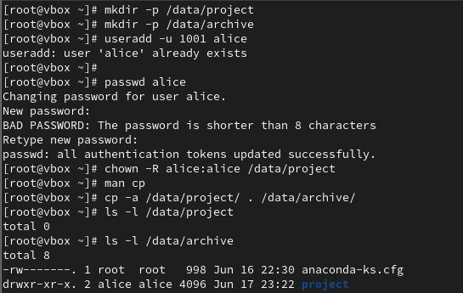

10. You want to generate a sequence of nested directories starting from /home/user/projects/2024/November. Neither the 2024 nor the November directory exists yet.

What single command would you use to generate the entire directory structure, ensuring that intermediate directories are created as needed?

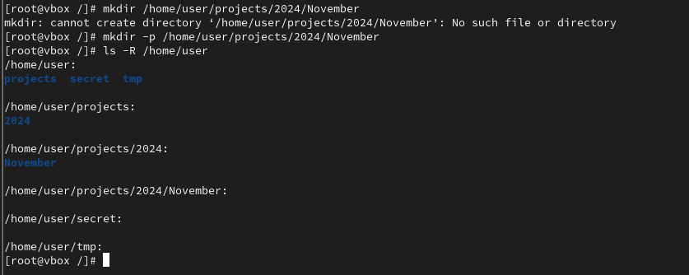

11. You need to delete the directory /home/user/tmp/test, which contains both files and subdirectories. Since rmdir only works with empty directories, how would you delete this non-empty directory and everything inside it in one command?

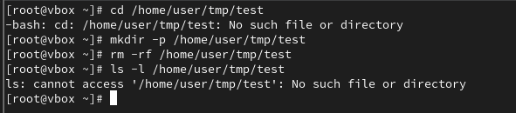

12. You are instructed to create a directory /home/user/secret with the following restrictions:

Only user should have full permissions on the directory.

No permissions should be granted to any other users.

Which command will you use to create this directory and enforce the correct permissions?  
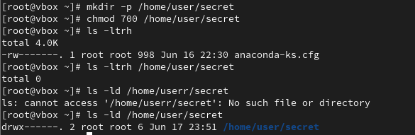

13. You need to change alice’s home directory to /home/alice_new. What command would you execute to achieve this?

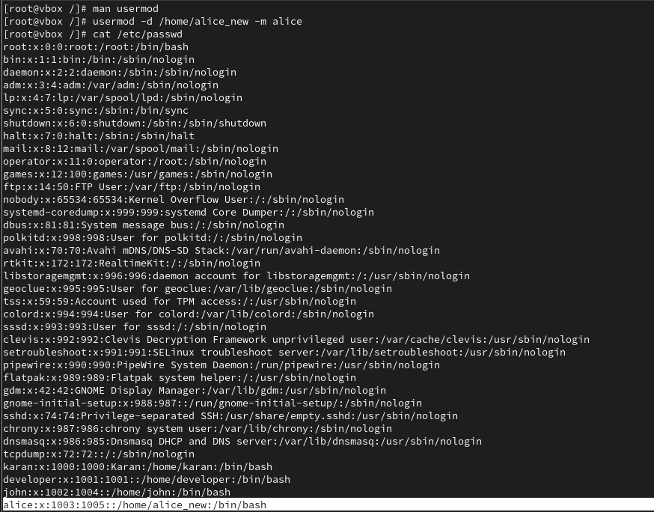

14. You are required to create a new partition with the ext3 filesystem type and mount it at /data. What command would you execute to create and mount the partition?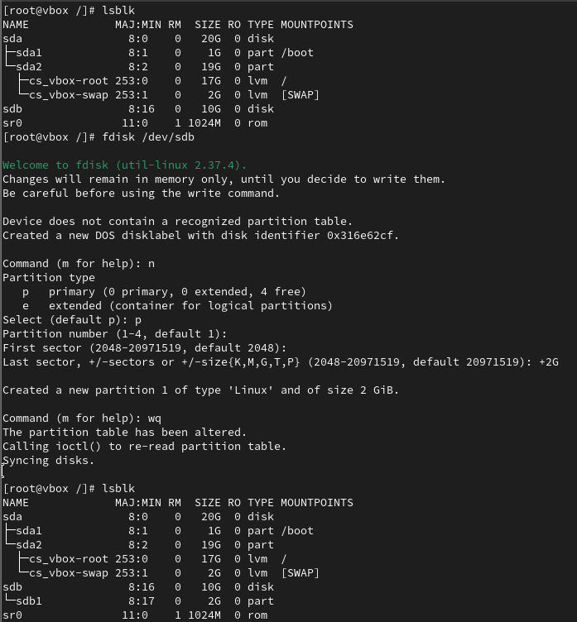

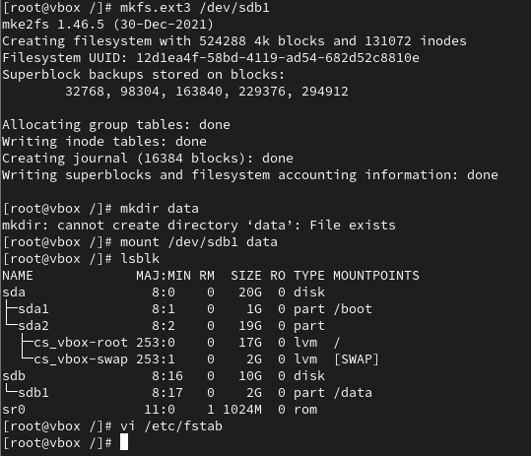

15. You must create a logical volume named database in the datastore volume group. The logical volume should:

Be 50 extents in size, with an ext3 filesystem.

The datastore volume group must have an extent size of 8 MiB.

Mount the logical volume at /mnt/database.

Provide the commands necessary for these actions.

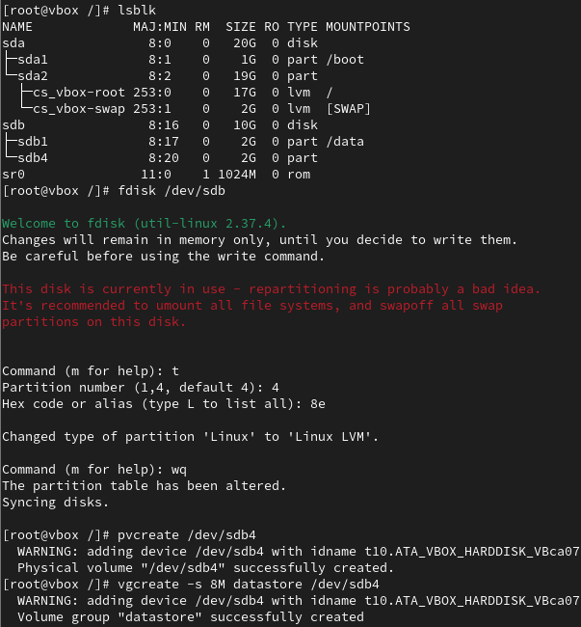

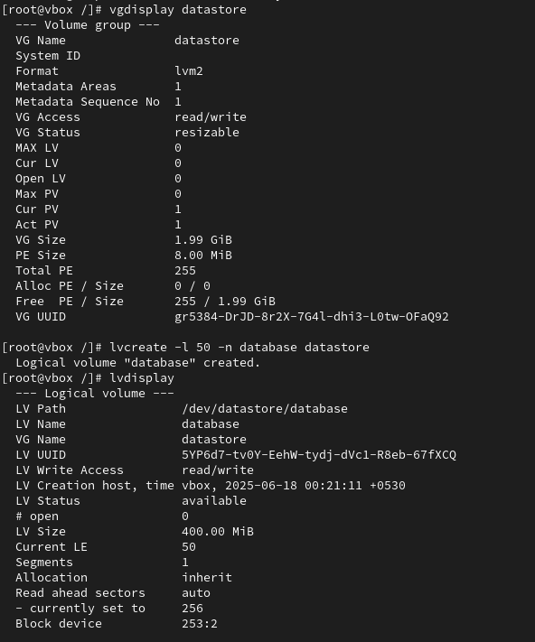

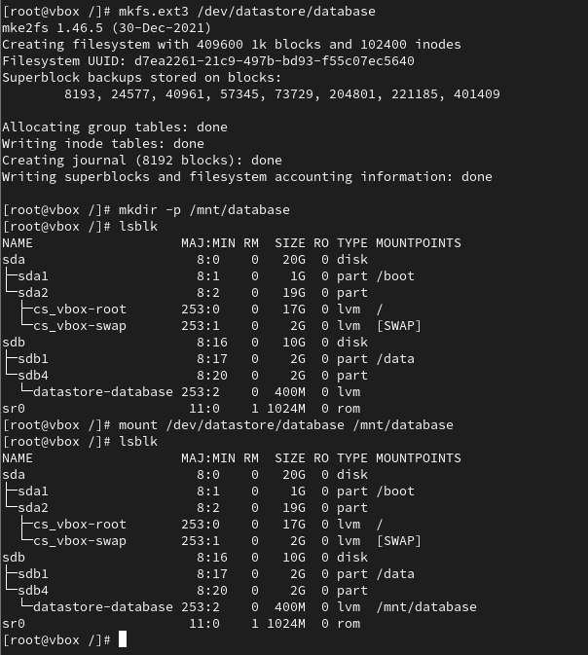

16. The logical volume mounted at /mnt/database is currently sized to 50 extents. You now need to increase its size by an additional 100 extents.

Write the commands to resize the logical volume accordingly.

You are required to create a swap partition of exactly 1 GB in size. What command would you use to create this partition?

